***Follett Destiny Online Library Access***

[Launch Pad](https://launchpad.classlink.com/rcboe) has made access to your school library much easier. There are so many things you now have at the click of a link or two.

First let start by getting into your account where you can see your library profile, checkout history, and fine information.

**Step 1:** Log into [LaunchPad](https://launchpad.classlink.com/rcboe)

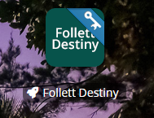

**Step 2:** Click on *Follett Destiny*

***Step 3:*** Click on *My Info*

***Step 4:***Review Items Out List and Match Barcodes

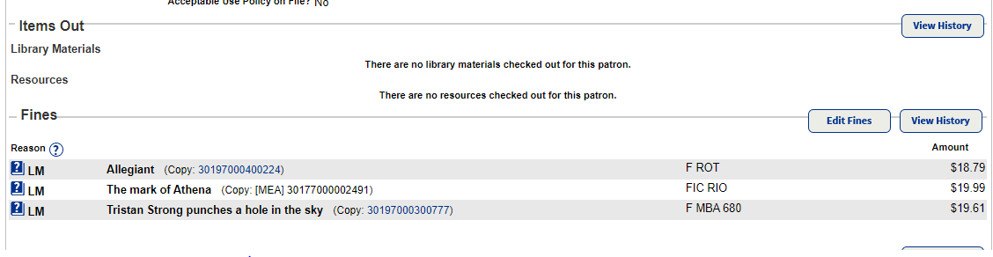

*NOTE:*  *You may have items out or fines from other schools. You will need to clear those at that school. Also should a fine appear in red, that means that item which you may have paid for already, has been refund to your account*.